|  |  |  |  |
| --- | --- | --- | --- |
| X | y | tempX | tempY |
| 0 | 5 | N/A | N/A |
| 1 | 6 | 1 | 7 |
| 1 | 7 | 1 | 7 |

A screenshot of a cell phone

Description generated with very high confidence

|  |  |  |  |
| --- | --- | --- | --- |
| J | K | L | Temp |
| 10 | 2 | 4 | N/A |
| 20 | 2 | 4 | 20 |
| 20 | 2 | 8 | 8 |
| 20 | 2 | 8 | 28 |
| 20 | 28 | 8 | 28 |

A picture containing screenshot, wall

Description generated with high confidence

|  |  |  |  |
| --- | --- | --- | --- |
| A | B | C | X |
| 1 | 10 | 100 | 0 |
| 1 | 10 | 100 | 300 |
| 1 | 10 | 100 | 360 |
| 1 | 10 | 100 | 365 |

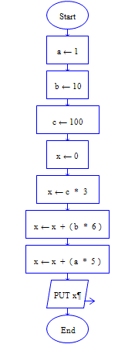

|  |  |  |
| --- | --- | --- |
| Area | Width | Length |
| 0 | 0 | 0 |
| 0 | 10 | 0 |
| 0 | 10 | 10 |
| 100 | 10 | 10 |

Declare grade, letter = 0, “F”  
While true do  
 output "Please enter the student's number grade."  
 input grade  
 if grade >= 0 and grade <= 100 then  
 break  
 else  
 output "Invalid input! Please enter a number between 100 and 0 (including 100 and 0)."  
End while

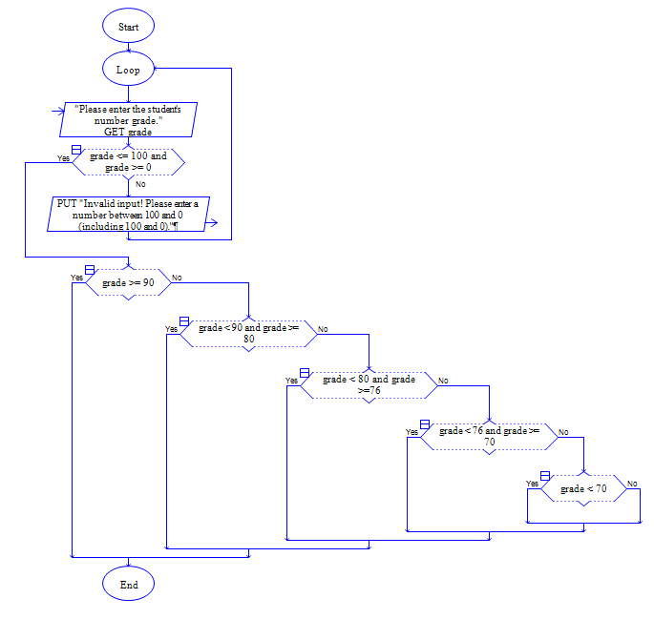If grade >= 90 then  
 letter = “A”  
 elseif grade < 90 and grade >= 80 then  
 letter = “B”  
 elseif grade < 80 and grade > 75 then  
 letter = “C”  
 elseif grade <76 and grade >= 70 then  
 letter = “D”  
 else  
 letter = “F”  
End If

|  |  |
| --- | --- |
| Grade | Letter |
| 0 | F |
| 92 | F |
| 92 | A |

A screen shot of a person

Description generated with high confidenceDeclare days[7] = 0  
Declare temp, avg, count = 0  
Declare good = false  
  
while good = false do  
 if count == 7 then  
 good = true   
 else  
 while good == false do  
 input temp  
 if temp >= 0 or temp <= 0 then  
 good = true  
 else  
 output “Not a valid input. Please input a number.”

|  |  |  |  |  |  |  |  |  |  |  |
| --- | --- | --- | --- | --- | --- | --- | --- | --- | --- | --- |
| Day[0] | Day[1] | Day[2] | Day[3] | Day[4] | Day[5] | Day[6] | Temp | Avg | Count | Good |
| 0 | 0 | 0 | 0 | 0 | 0 | 0 | 0 | 0 | 0 | false |
| 75 | 0 | 0 | 0 | 0 | 0 | 0 | 75 | 0 | 1 | false |
| 75 | 70 | 0 | 0 | 0 | 0 | 0 | 70 | 0 | 2 | false |
| 75 | 70 | 80 | 0 | 0 | 0 | 0 | 80 | 0 | 3 | false |
| 75 | 70 | 80 | 77.5 | 0 | 0 | 0 | 77.5 | 0 | 4 | false |
| 75 | 70 | 80 | 77.5 | 72.5 | 0 | 0 | 72.5 | 0 | 5 | false |
| 75 | 70 | 80 | 77.5 | 72.5 | 75 | 0 | 75 | 0 | 6 | false |
| 75 | 70 | 80 | 77.5 | 72.5 | 75 | 75 | 75 | 0 | 7 | true |
| 75 | 70 | 80 | 77.5 | 72.5 | 75 | 75 | 75 | 75 | 1 | false |
| 75 | 70 | 80 | 77.5 | 72.5 | 75 | 75 | 75 | 145 | 2 | false |
| 75 | 70 | 80 | 77.5 | 72.5 | 75 | 75 | 75 | 225 | 3 | false |
| 75 | 70 | 80 | 77.5 | 72.5 | 75 | 75 | 75 | 302.5 | 4 | false |
| 75 | 70 | 80 | 77.5 | 72.5 | 75 | 75 | 75 | 375 | 5 | false |
| 75 | 70 | 80 | 77.5 | 72.5 | 75 | 75 | 75 | 450 | 6 | false |
| 75 | 70 | 80 | 77.5 | 72.5 | 75 | 75 | 75 | 525 | 7 | true |
| 75 | 70 | 80 | 77.5 | 72.5 | 75 | 75 | 75 | 75 | 7 | false |

End if  
 End while  
 count = count + 1  
 days[count] = temp  
End while  
  
count = 0  
while good = false do  
 if count == 7 then  
 good = true  
 else  
 count = count + 1  
 avg = avg + days[count]  
End while  
  
avg = floor(avg / 7 )  
output “The average for the week is “ + avg + “ degrees.”